- Open the SampleSuperstore.csv file in Excel and use the Filter and Remove Duplicates features to clean the data so that each Order ID appears only once.
ANSWERS:
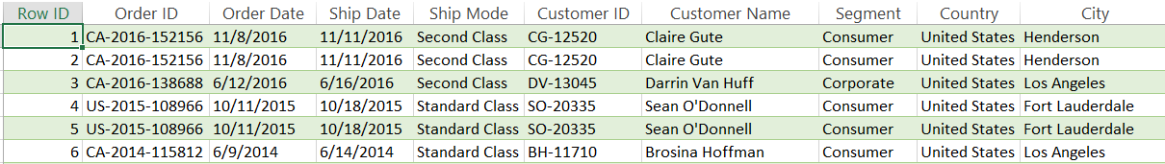

- Create a Pivot Table to analyze total Sales and Profit by Region, and highlight which region has the highest profit.
ANSWERS:
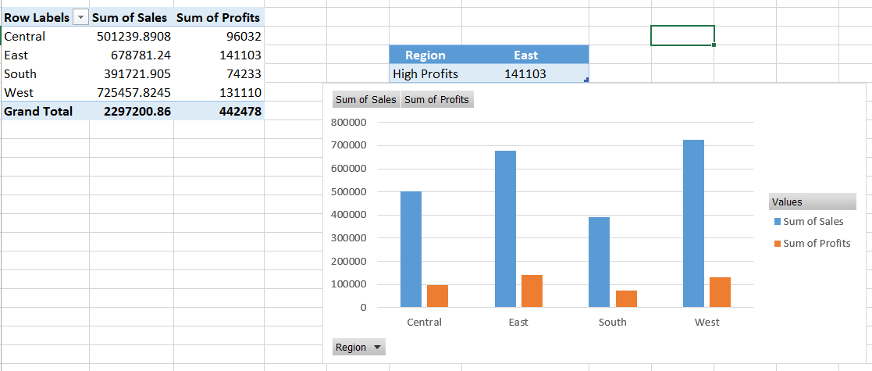
- Use Conditional Formatting to visually identify orders where the Discount is greater than 20% and the Profit is negative.
ANSWERS:
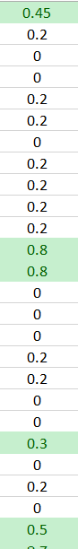

- Design a simple dashboard on a new Excel sheet that displays total Sales, total Profit, and a bar chart of Sales by Category using data from the SampleSuperstore.csv file.
Hint: Use Pivot Charts and summary formulas like SUM and COUNT.
ANSWERS:

- Use Excel's Quick Analysis or Recommended Charts tool to create a visualization that shows the top 5 most profitable Sub-Categories, and briefly describe your findings in a comment box.
ANSWERS:

Binders Sub-Category has Highest total Profit.

